Affection of the respiratory system (chest wall and chest contents).
الساعة الاولى المحاضرة الاولى
Anatomy.  Physical consideration of respiratory system.  - Affection of the chest wall.  - Congenital abnormalities.  الساعة الثانية المحاضرة الاولى  - Pectus Excavatum.  - Acquired lesions.  - Contusion wound (trauma).  - Ribs fracture.  - Fracture of the ribs cartilage.  الساعة الاولى المحاضرة الثانية  - Sternum fracture.  - Open wound.  - Ribs fistula.  - Sternum fistula.  - Neoplasms of the thoracic wall.  - Affection of the chest contents  الساعة الثانية المحاضرة الثانية  - Diseases of Pleura.  - Affections of the diaphragm.  - Affections of the lungs and. bronchi.  - Affection of the mediastinum.  - Other thoracic lesions.  الساعة الاولى والثانية المحاضرة الثالثة  Surgical approach to the chest cavity. | 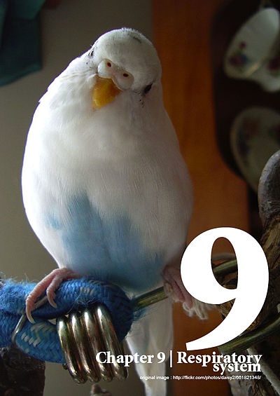

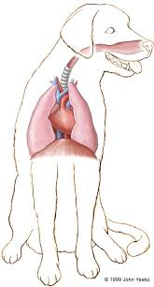
Anatomy
- The respiratory system is composed of
- The nares (nostrils), nasal cavity, sinuses within the skull.
- Pharynx (back of the mouth).
- Larynx (voice box).
- Trachea (windpipe). Incomplete rings of cartilage
- Bronchi, bronchioles, alveoli (tracheal branches into lungs).
- The lungs have right and left lungs, just like humans

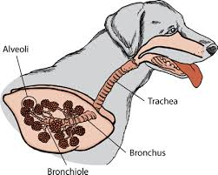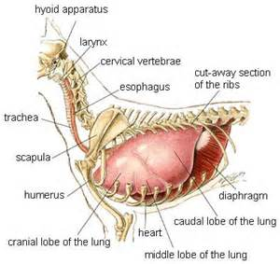

- The lungs are further divided into sections, or lobes. Covered with pleura separated from the abdominal cavity by diaphragm.
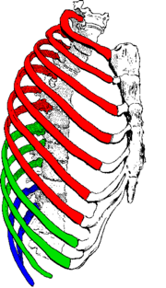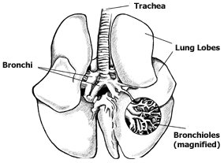
- The mediastinum In humans and sheep it separates the cavity completely so that puncturing one pleural cavity leads to the collapse of only one lung. In dogs, this separation is incomplete so a puncture results in a complete collapse of both lungs.
- True ribs that articulate directly with the sternum.
- False ribs that connect indirectly via cartilage
- Floating ribs which are freely and not connected to any part.

Physical consideration of the respiratory system
- Once the first breaths are taken after birth, a puppy has a fully functional respiratory system.
- Animals need to breathe to supply the cells with oxygen and remove the waste product carbon dioxide. Control the body temperature (cooling system since dogs do not have sweat glands except on their feet), blood pressure, and acid base balance.
- Gas exchange occurs in the alveoli here oxygen diffuses from the alveoli into the red blood cells in the capillaries that surround the alveoli. Carbon dioxide, at high concentration in the blood, diffuses into the alveoli to be breathed out.
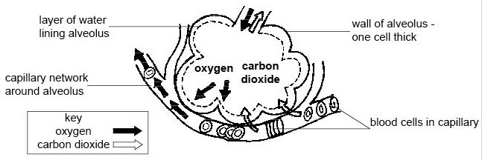
- Inspiration occur when muscle contraction causes the ribs to move up and out and the diaphragm to flatten. These movements increase the volume of the pleural cavity and draw air down the respiratory system into the lungs.
- Expiration is a passive process requiring no energy as it relies on the relaxation of the muscles and the elastic tissue of the lungs.
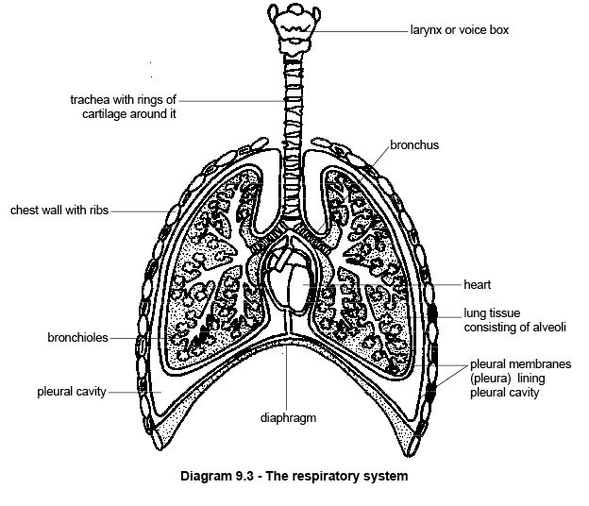
- The respiratory centers in the hind brain control the rate of breathing. They respond to the carbon dioxide level in the blood.
- Collapsed Lungs occurs if punctured by a broken rib.
PRINCIPALES LEADS TO RESPIRATORY INSUFFICIENCY
(I) Anoxia: low level of oxygen to the tissues, Types of anoxia:
1-Anoxic anoxia: a defective oxygenation of the blood in the pulmonary circulation
2- Anemic Anoxia a deficiency of hemoglobin per unit volume of the blood.
3-Stagnant Anoxia: the rate of blood flow through the capillaries is reduced
4-Histotoxic Anoxia the blood is fully oxygenated, but because of the failure of the “tissue oxidation system.
(II) Carbon dioxide retention "Hypercapnea": high level of CO2 in blood
(III) Respiratory failure: Respiratory movements are controlled by respiratory center in the medulla
Clinical signs of respiratory insufficiency
1-Hyperpnea & dyspnea: - Hyperpnea is defined as increased pulmonary ventilation. - Dyspnea means difficulty of respiratory.
2-Cyanosis: Definition: It is a bluish discoloration of the skin, conjunctiva & visible mucosa
3- Cough:
4-Nasal discharge:
- Abnormal nasal discharge.
- Mucoid or purulent discharge presence of inflammation in the nasal cavities or paranasal sinus.
- Frothy exudates indicate pulmonary congestion or odema.
- Small amount of serofrothy.
- Color
- may be greenish in gangrene,
- Yellowish rusty in pneumonia &pleurisy.
- Amount
- Could be slight in T.B.
- Profuse in rhinitis or intermittent in sinusitis.
- Odour
- offensive in gangrene,
- Bad in cyanosis.
5-Abnormal respiratory sounds: rales & frictional sounds.
Normal respiratory sounds vesicular & bronchial sound.
Affection of the chest wall
- Congenital abnormalities
- Acquired lesions

Congenital abnormalities
Pectus Excavatum:
- Pectus excavatum is an unusual deformity of the breast bone
- Depression of the sternum is seen occasionally.
- Finding during respiration or radiographic examination
- Associated with respiratory distress and collapse.
- Surgical intervention is not recommended.
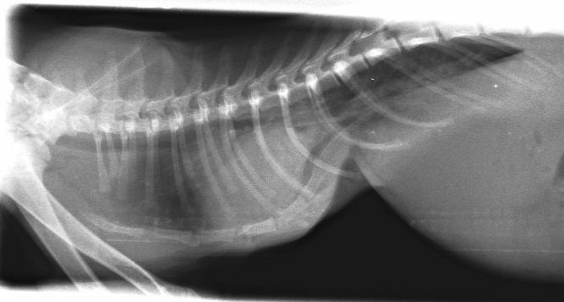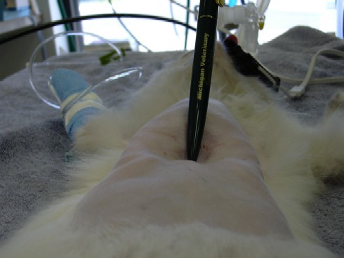
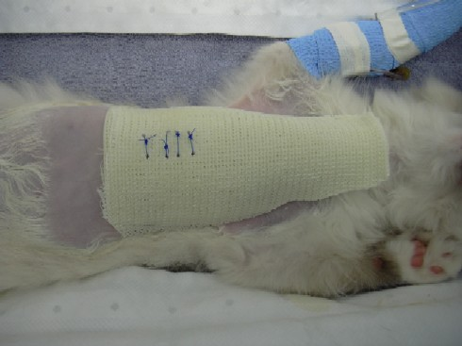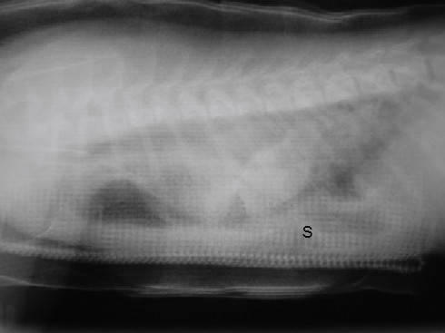
Acquired lesions
- Contusion wound (trauma).
- May be of first, second, or third degree , involve the skin, ribs or muscles ,severe contusion leads to bleeding in the under lying tissues and muscles ,resulting in chest hematoma.
Signs:
- Inflammation around the skin side,Local simple swelling,
- Cutenous Frothy hematoma with chest pain
- Nostrils exudates characterized by frothy bloody bubbles
- General hematoma and swelling along the neck
- large size hematoma In the second degree during bleeding of the intercostals blood vessels, may reach the third degree.
- The third degree the damage of the subcutaneous tissues may reach to the ribs fractures.
Complications:
- Contusion of the internal organs even with no ribs fractures.
- Lung tearing occurs due to the perforation of the sharp end of rib fracture leading to this tearing with or without plural rapture
- Plural Pneumothoracic.
- Plural hemothoracic
- Heart and large thoracic blood vessels rupture (In the large animals during anesthesia and fowling down on hard ground).
Prognosis:
- Contusion wound without complication to the internal organ removed spontaneously or may need surgical intervention.
- In the severe case with tearing to the lungs and plural viscera mostly recovered.
- In the more severe case may lead to death (because of the internal bleeding, asphycseia due to hemothoracic and heart damage and tearing of the large blood vessels).
Treatment:
- Complete rest with Cold application in resent contusion wounds
- Remove the hematoma after 8-10 days from the accident
- Pain killer ,Fluid therapy and Course of antibiotics to avoid the complications.
- Ribs fracture
- Fractures can occur across the bony part of the ribs, or the cartilaginous breast bone or sternum.
- The common causes are road traffic accidents.
- If only one rib is broken there may be few clinical signs, more than one rib is broken the animal have great difficulty breathing.
- painful so pain relief and supporting bandage was given
- Single rib fractures will heal quite well with rest, but if the rib is displaced or multiple rib fractures with lung damage surgically repair using wires. In severe cases, "splint" outside the chest wall to hold the ribs in place.
- Trauma cause a rib fractured and soft tissue injury (lungs). In addition, there may be internal hemorrhage, if air can enter the chest cavity causing the lungs collapse (pneumothorax).
- Rib number 6 to 11 is the most ribs which exposed to fractures because these ribs are more prominent in the chest wall
- Fracture may be complete or incomplete or simple or compound or comminuted.
- Simple and stable or non displaced fracture characterized by local inflammatory sweeling, with creptation sound, persistent cough.
- Displaced fracture accompanied with rib deformity, and in case of many ribs involved the type and rate of breathing may be changed with pain and may affect the partial pleura.
Complication of the ribs fractures
- Perforation the lung ,heart ,and thoracic vessels by rib
- Perforation of the thoracic wall
- Radial paralysis occurs when the first rib is broken
- Bleeding of the intercostals artery
Treatment:
- Complete rest until the fracture is repaired
- Stable fracture (undisplaced fracture) needs just rest, and cold application with local irritant drugs. Slight displaced fracture needs traction with principles of fracture healing.
- Chip bone must be remove with caution not to penetrate the plural membrane and cavity ,and remove the new formed fibrous tissues
- Stop bleeding of the intercostals vessels with routine hemostasis, the big blood vessels need legated
- Ribs fistula may occur due to necrosis of the rib or chip of bone located deep in soft tissues.
- Fracture of the ribs cartilage:
Characterized with out of crepitation sound, and the healing by ossification of the cartilages fragments.
- Sternum fracture:
- Occurs mainly in large size animals (ruminants) during sudden failing, during anesthesia or lying for long period on stable hard materials
- Rarely in small animals.
- The fracture may be simple or compound, complete or in complete.
Signs and treatment: same in the contusion thoracic wounds or open wound and Cautions when dealing with the hematoma to prevent the infection in the affected area.
Diagnosis:
- Difficult to diagnosis because of the heavy musculatures layer
- Crepitation sound during the animal moving or breathing.
- In the advanced and complicated case the identification by the infected wound which mostly lead to sternum fistula
- Open wound:
Perforating or none perforating wound, or deep or superficial wound which lead to subcutaneous emphysema, Occurs due to external trauma or materials which used for tighten around the back and abdomen, these may be
Signs and diagnosis:
- Difficult to recognize the opening in deep and narrow wound
- In wide deep wound can see the thoracic contents
- Hearing the sound of air when entering the chest.
Complication:
- Lungs collapse:
Entering of the air in the thoracic cavity due to the negative pressure. Medistinum Rupture lead to lung collapse in small animal and horse but in the ruminant the medistinum strong and can open one side of the lung, which is similar to the human
- Pneumothoracic:
Because of the entering of air during inspiration and when expiration the air may be diffused and accumulate and finally lead to pressure on the lungs.
- Hemothoracic:
healing occurs and blood absorbed in Small quantity of blood and air, large quantity lead to death and be source of infection
- Pluritis:
May be fatal or may healing slowly and take week or months.
- Perforation of the lungs,heart,and blood vessels:
Recoved spontaneously no infection occurs but fatal, in case of infection or penetration of the aorta may be.
- Bleeding of the intercostals artery:
Rapture of the large blood vessels
- Perforation of the abdominal cavity by the diaphragm:
Penetrate the stomach and intestine leading to diffuse peritonitis
Treatment:
- Same in the deep wound Close the wound with applying deranged
- not allow the antiseptic agent to enter the thoracic cavity
- In complicated case (lung prolapsed) clean the affected organ with give rest to animal Remove the lacerated or necrotic part of lung (lobactomy).
- Ribs fistula:
Is like a sinuses have affinity to produce pus on the thoracic wall, due to rib necrosis or a foreign body deep in the inter costal muscles.
Signs:
- same as of the signs of sinuses
- Insert the prop inside the sinuses to determine the location of bone or foreign body or even spongy bone (necrotic bone).
Treatment:
- Irrigate the sinuses with antiseptic solution
- Hot iron inside the sinuses may be mostly succeed
- Surgically by open the sinuses and clean the content, remove the necrotic tissues.
- May need remove part of infected rib (prepare the area, sloughting the periostum; remove the rib by wire saw).
- Adhesion and fibrosis of the inflamed plural membrane protect the infection from entering inside the thoracic cavity
- Close the wound and using dressing bandage.

- Sternum fistula:
- Occurs as a result of infected wound due to external trauma and sternum fracture or part of bone.
- Using the prop to determined the depth of the wound especially when crushed with sternum or the foreign bony body.
- Chance for pus formation and pyothorax ( empyema) occurs when the infection reach the thoracic chamber.
Prognosis:
The treatment is useless, not economic and need long time for repair or even not repaired
Treatment:
- Remove the cause (the foreign body, piece of bone or even the necrotic bone).
- Be caution not to open the thoracic wall
- Treat the sinuses as the routine manner.
- Neoplasms of the thoracic wall:
- Large breeds and over 5 years age are more susceptible for affected.
- Common for lipoma and others neoplasms.
- The most important tumors osteosarcoma and chondromas involving the ribs.
- Metastasis to the lung is common.
- Treatment and prognosis depend on tumors characteristics and the prognosis is poor after surgical removal.
- Treatment most be done by surgical removal the lesion and part of normal tissues.
- Hypertrophic osteoarthropathy may be associated with rib tumors.
- Diagnosis is assessed by Radiography.

Affection of the chest contents.
- Diseases of Pleura :
Pleural effusion:
Accumulation of fluids or exudates in the pleural sac, results from:
- Diaphragmatic hernia.
- Neoplasia.
- Lung torsion
Clinical signs:
- Depend of the rate, typ volume of accumulation.
- Dyspenea
- Reduced exercise tolerances are common.
- Lethargy (الخمود ).
- Anoxia.
- Coughing.
- Reluctance (التردّد) to lie down and abduction of the elbows.
Diagnosis:
- Case history.
- From the clinical signs
- Physical examination, abnormal respiratory and heart sound, dull sound.
- Laboratory examination such as
- Gross appearances of protein contents.
- Total cells count and morphology of cells.
- Bacterial and fungal culture.
- Specific test such as fat staining
- Radiography.lateral and dorso ventral view ( the un clear exposure is due to the increase density which caused by plural fluids and parital atelectasi of the lung) ,it is best to taken after remove the fluids
- Thoracentesis, best done for animal health and condition and for radiography examination and for the Laboratory examination of the aspirated fluids.
- Exploratory thoractomy, better to be done on the accumulation fluids side otherwise in the sternum thoractomy, if the clinical signs and radiography is no enough to confirm the diagnosis.
Pyothorax (empyema): accumulation of pus due to infection caused by nocardia, actinomycosis injuries of the thoracic wall (even surgical wounds).
Chylothorax: accumulation of the milky or brown-tinged fluid, contain fat droplets caused due to rupture of thoracic ducts, one or more of its branches, neoplasia, or truma
Hydrothorax: presence of non inflammatory fluid in pleural sac. Treated by aspiration fluid which reaccumulates rapidly again.
Hemothorax: presence of blood in the pleural sac.
Treated by 1-parentral coagulants. 2-Blood transfusion.
Pneumothorax: entry of the air in the pleural sac in a sufficient quantity to cause collapse of the lung.
Treated by
- Closure of the thoracic wound by surgical means &
- Keep the animal quite.
- Give prophylactic treatment.

Neoplasms:
- Occurs in older dogs.
- Dyspenea is occurs as results of fluid effusion.
- Diagnosis is made by cytological examination of plural fluids.
- Aspiration of the fluids will provide temporary relief.

- Affections of the diaphragm:
- Congenital abnormalities
- Acquired lesions
Congenital abnormalities
Peritoneopericardial (congenital diaphragmatic) hernia:
- Common condition Characterized by Vomiting,anorexia.lethargy, dyspenea, and diarrhea
- Incomplete separation of the peritoneal and pericardial cavities.
- Diagnosis by physical examination, intestinal sound heard in the thorax, muffled heart sound, increased dull sound in the ventral area, Radiographs reveal increase the size of the pericardial shadow, Exploratatory thoracotomy.
- Surgical treatment through ventral midline
Acquired lesions:
- Traumatic diaphragmatic hernia:
- rare in farm animals except in cattle especially association with traumatic reticulo-peritonitis, the hernia is small
- Usually occurs by blunt trauma.
- Lungs contusion or shock may present with Colic & dyspnea
- Characterized by Sitting position with elbows abducted
- Intestinal sound in the thorax with muffled heart sound reduced lungs sound, increased dull sound.
- Diagnosis by clinical signs, reduced exercise tolerance radiography, (contrast studies by barium sulphate), dyspenea especially when the animals elevated on the hind or fore limbs.
- Treatment by surgical procedures.
- Hiatal hernia:
- Form of diaphragmatic hernia.
- The caudal end of the esophagus and cardic area of the stomach pass through the esophageal hiatus of the diaphragm.
- Vomiting and others signs associated with esophagitis.
- Surgical treatment to reduce hernia and reconstruction diaphragm.
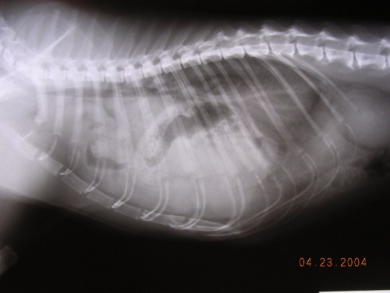
- Affections of the lungs and bronchi:
- Congenital abnormalities
- Acquired lesions.
- Congenital abnormalities
Cysts.
- Is rare, may be blind or filled with white fluid or air or pus.
- When cyst is ruptures pnemothorax in the pleural cavity occurs.
- Acquired lesions.
- Pulmonary contusion.
Increase density in radiography, hemorrahage into pulmonary parachyma.associated with dyspenea, rales may be heard on auscultation, positive – pressure ventilation may be require.
- Torsion of the lung lobe
Occurs following trauma, need surgical removale.
- Solitary lesion of the lungs
Diagnosed by radiography of the thorax, associated with chronic cough, not restricted to one area, localization lesions (laceration, torsion, tumors, abscess, and bronchiectesis ) treated surgically.
- Localized chronic infection in pulmonary lobe.
- Rare, occurs with incidence of migration grass awns (ريش سنابل عشبِ), and fungal or parasitic diseases.
- The clinical signs were cough, treated with antibiotics and surgical remove of affected part.
- Diagnosis by radiography, history of not response to treatment, it is difficult to differentiate the lesion in which lung lobe and can identify by bronchography or bronchoscopy or fluoroscopy. With culturing for bacterial and fungal growth
- Bronchiectesis.
- Permnant dilatation of the bronchioles mostly in mature dogs
- Usually is accompanied with low –grade infection
- Rarely diagnosed
- Results due to obstruction or collapse or acomplication of bronchopneumonia, tracheobronchitis or chronic bronchitis.
- Associated with Fever cough persist for long time and initiated by exercise or excitement , dry then change to moist
- Diagnosis by case history, radiographic examination
- Medical and surgical Treatment, (resection the infected lobe).
- Neoplasms of the lungs and bronchi.
- Metastases is the common neoplasms, Can be single or multible (lobectomy is performed to remove the mass).
- Characterized by recurrent signs of pulmonary disease, or signs which not responed to treatment.
- Should be differentiated between the neoplsia and chronic localized infection is immposible, Diagnosis by radiography, percutenous aspiration.
- Treated by lobectyomy. Prognosis is poor
- Affection of the mediastinum:
- Mediastinal neoplasms:
- Lymph sarcoma is most common
- Associated with pleural effusion, dyspenea, regurgitation, edema of the head and neck lead to pressure on the cranial vena cava.
- Diagnosis by
- thoracentesis ,cytological examination of the fluids,
- radiographic examination for revealing foreign mass
- Surgical treatment with poor prognosis
- Pneumomediastinum and mediastinitis.
- Results from rupture of the thoracic trachea or esophagus.
- Diagnosis by Radiography.
- Pneumothorax, Cervical Subcutaneous emphysema, pneumomediastinum and hemoptysis , Poor prognosis.
- Other thoracic lesions:
Hypertrophic osteoarthropathy:
- Periosteal New bone formation of the distal ends of limbs.
- The cause is blood flow impairment by the space –occupying lesion in the thorax and abdomen ( thoracic neoplasm, when surgically removed the blood flow increased to the limbs and the new periosteal formation gradually resorbed)
- Hot, swolling, painful limbs.
- Radiographic examination shows new bone formation known as lacy, lamellar, or scalloped.

Surgical approaches to the thorax include:
- Thoracentsis (thoracocentesis):
- Thoracotomy
- Median sternotomy.
- Lateral thoractomy
- Intercostal (posterolateral and anterolateral) thoracotomy.
- Rib section incision
- Resection 5th Rib thoracotomy

Anesthetic considerations
- Patients may be well and, stabilization.
- A premedication should be given.
- Inject able Anaesthesia or inhalation or a combination of two.
- NSAIDs can given perioperatively if no contra-indications
- Ventilation either manually or using a mechanical ventilator.
- Monitored the: heart rate and rhythm, capillary refill time, pulse quality, ECG, blood pressure, and body temperature.
- Arterial catheters are useful for serial blood gas analysis.
- Intravenous fluids should be warmed when necessary.
- Irrigation with warmed fluids
- Irrigation with cool fluids will rapidly cause hypothermia.
- Hypotensive Patients frequently can lead to renal hypoperfusion.
- Gentle handling tissues, manipulation of the vagus nerve can cause a sudden and profound bradycardia, Retraction of the mediastinum can occlude the caudal vena cava, and handling of the heart can cause arrhythmias.

The following important assistant
• Local anaesthetic to place an intercostals block at the surgical site
• Retractors placed and the tissue are protected with moistened swabs
• The fluid is removed by suction.
• A chest drain (thoracostomy tube) and when close the wound, evacuates air from the pleural cavity using a syringe and a three-way tap, or one-way centesis valve

Postoperative care
- The immediate priorities are to maintain respiratory function and to provide sufficient analgesia (this is essential as any pain associated with movement of the thoracic wall may further compromise respiratory function).
- respiratory rate and character, should be monitored
- Airway – the airway may need to be suctioned
- Postoperative oxygen should be provided
- Patients should be on sternal recumbency to allow maximum inflation of both lungs. Lateral recumbency in lung lobectomy or pneumonectomy may prove fatal (if the left lung is removed and the animal is recovered in right lateral recumbency then it may not adequately oxygenate its remaining lung).
- An Elizabethan collar may be used to prevent patient interference
Thoracentsis (thoracocentesis):
Is a procedure performed to removing an excessive quantity of fluid from the pleural cavity, or used for the diagnostic purposes or used prior to the radiographic examination by inserting a hollow needle or trocar into the pleural cavity.
In the horse from the left side at the 8th intercostals space just above the vein close to the anterior border of the rib, while on the right side is performed at the 7th intercostals space.
The technique is:
- Prepare the area (clipping, shaving, wash with soap and water then disinfect the area).
- Push the skin upward (the puncture thru the skin and the muscles will not communicate directly).
- Slow push the instrument thru the tissue until feel resistance (still hold the instrument with finger).
- When the fluid has flowing freely, a rubber tube should be attached with one end of the instrument and the other end should be inserted below the surface of a liquid (to prevent the aspiration of air into the plural cavity).
- Remove the instrument and cove the opening of the skin.
Thoracotomy:
is an incision performed into the pleural space of the chest to access (الوصول) to the thoracic organs, heart, lungs (lobectomy or pneumonectomy), esophagus, thoracic aorta or the anterior spine .
- Requires general anesthesia with endotracheal tube insertion and mechanical ventilation.
- One of the most difficult surgical incisions deals with post-operatively, because they are extremely painful and the pain can prevent the patient from breathing effectively, leading to atelectasis or pneumonia.
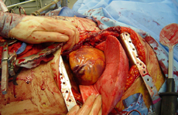
Different approaches to thoracotomy
- Median sternotomy
Provides wide access to the mediastinum and is the incision of choice for most open-heart surgery and access to the anterior mediastinum.
- Posterolateral thoracotomy
Is an incision through an intercostals space on the back, and is often widened with rib spreaders. It is a very common approach for operations on the lung or posterior mediastinum, including the esophagus. When performed over the fifth intercostals space, it allows optimal access to the pulmonary hilum (pulmonary artery and pulmonary vein) and pulmonary resection (pneumonectomy and lobectomy).
- Anterolateral thoracotomy:
Left anterolateral thoracotomy is incision performed for open chest massage, a critical maneuver in the management of traumatic cardiac arrest. Requires the use of tissue retractors. Bilateral anterolateral thoracotomy combined with transverse sternotomy results in the "clamshell" incision, the largest incision commonly used in thoracic surgery.
- Rib section incision:
Technique is performed to reach the chest cavity thru the incision of the skin over the rib and dissecting the muscles and ribs perostium, and cutting the ribs and opening the periostium and pleura to reach the pleural cavity.
- Closed the chest .
- One or more chest tubes—with one end inside the opened pleural cavity and the other submerged under saline solution inside a sealed container, forming an airtight drainage system—
- Necessary to remove air and fluid from the pleural cavity, preventing the development of pneumothorax or hemothorax.
- Post operative pain (Thoracotomy pain syndrome), continued pain can last from a few years to a life time of and discomfort. Treatment to aid pain relief for this condition includes intra thoracic nerve blocks.
Resection of the Fifth Rib:
Is an operation which may be done in the ruminants to provide access (الوصول) to the pericardial sac, in that the pericardial sac is usually distended with variable quantities of purulent excaudate in some case of traumatic pericarditis.
- High mortality rate in traumatic percarditis, due to unfavorable pathological changes.
- The operation performed to save the patient.
- Can be done in dogs in case of heart worm diseases to pick or remove the adults worms,which it easy to reach the right ventricles or the beginning of the pulmonary arteries.
Techniques of the operation:
- Determined the fifth rib counting nine ribs forward from last rib.
- Prepare the site of operation as a routine manner, anesthesia by local infiltration to the skin and subcutaneous tissues over the section of the rib to be removed.
- One inch Skin incision over the rib below the costo-chondral articulation upward for six- eight inches and five inches wide.
- Dissect the soft tissues from the surface of the rib and both anterior and posterior edge (avoid damaging to the blood vessels at the posterior border of the rib).
- Remove four or five inches from the distal end of the fifth rib using obstetric wire saw.
- Carful dissect the pleura from the medial side of the rib by finger.
- The pleura is exposed and freely incised (the pericardium and the pleura is usually adhered, a small opening is made in the pleura).
- Opening the pericardium, (remove the purulent exadute and foreign bodies then irrigate with antiseptic solution).Close the skin incision.

